- Open Komplexiti (https://www.korovatron.co.uk/komplexiti/)
- Add the constant $a=1$ to the panel.
- Add the expression $a+\overline{a}$ to a second card.
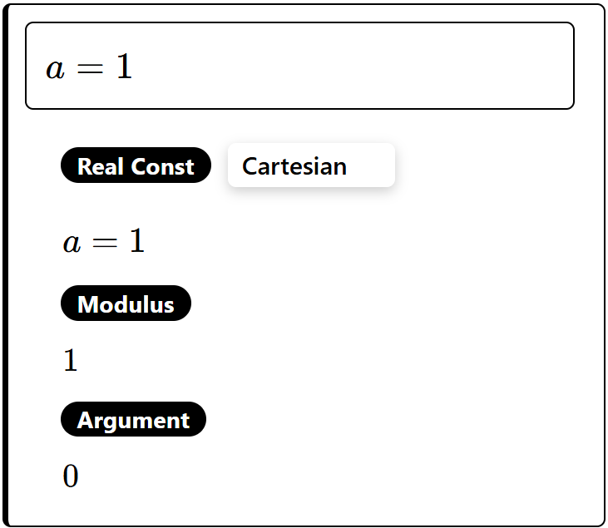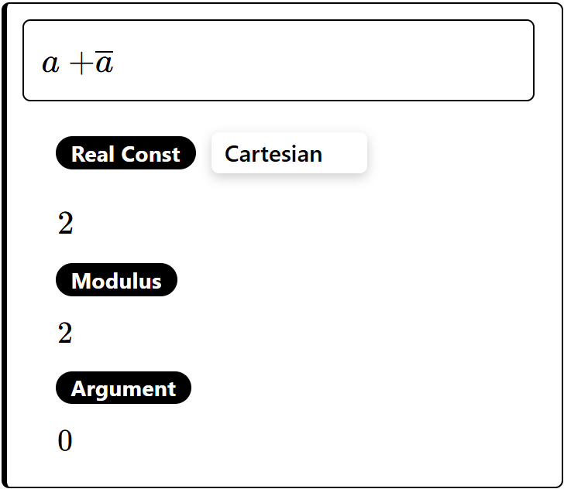
Type conj(a) to enter $\overline{a}$

For each of the following expressions use the mouse to drag the point a around the Argand diagram and observe what happens.
$$a+\overline{a}$$  Describe how $a+\overline{a}$ behaves as you drag the point $a$ around the Argand diagram.  It is confined to the real axis, twice as far from the imaginary axis as a.  Can you prove what you have discovered?  $$a=x+yi$$  $$\overline{a}=x-yi$$  $$a+\overline{a}=x+yi+x-yi$$  $$a+\overline{a}=2x$$ | $$a-\overline{a}$$  Describe how $a-\overline{a}$ behaves as you drag the point $a$ around the Argand diagram.  It is confined to the imaginary axis, twice as far from the real axis as a.  Can you prove what you have discovered?  $$a=x+yi$$  $$\overline{a}=x-yi$$  $$a-\overline{a}=x+yi-\left(x-iy\right)$$  $$a-\overline{a}=2yi$$
$$a\overline{a}$$  Describe how $a\overline{a}$ behaves as you drag the point $a$ around the Argand diagram.  It is confined to the positive real axis.  Can you prove what you have discovered?  $$a=x+yi$$  $$\overline{a}=x-yi$$  $$a\overline{a}=\left(x+yi\right)\left(x-yi\right)$$  $$a\overline{a}=x^{2}+y^{2}$$  $$∴a\overline{a}≥0$$ | $$\frac{a}{\overline{a}}$$  Describe how $\frac{a}{\overline{a}}$ behaves as you drag the point $a$ around the Argand diagram.  It is confined to the circle centre (0, 0), radius 1.  Can you prove what you have discovered?  $$a=x+yi$$  $$\overline{a}=x-yi$$  $$\left|a\right|=\sqrt{x^{2}+y^{2}}$$  $$\left|\overline{a}\right|=\sqrt{x^{2}+y^{2}}$$  $$\left|\frac{a}{\overline{a}}\right|=\frac{\left|a\right|}{\left|\overline{a}\right|}=\frac{\sqrt{x^{2}+y^{2}}}{\sqrt{x^{2}+y^{2}}}=1$$  $∴\frac{a}{\overline{a}}$ is equidistant from the origin,  so is a circle centre (0, 0),  radius 1.

